August
3rd Parent Orientation (mandatory) 6:00pm
7th First day of school

September
4th No School - Labor Day (observed)
25th Apple Farm Field Trip

October
9th Pumpkin Patch Field Trip
19th Great Shake Out
24th & 25th Fall Picture Day @ 9 AM
30th & 31st Harvest Parties

November
10th No School - Veterans Day (observed)
20th & 21st Family Thanksgiving Feast
23rd & 24th No School - Thanksgiving Break

December
13th Christmas Program 6:30 pm
21st & 22nd Christmas Parties
22nd School closes at 12:00pm
23rd – Jan 1st No School - Christmas Break

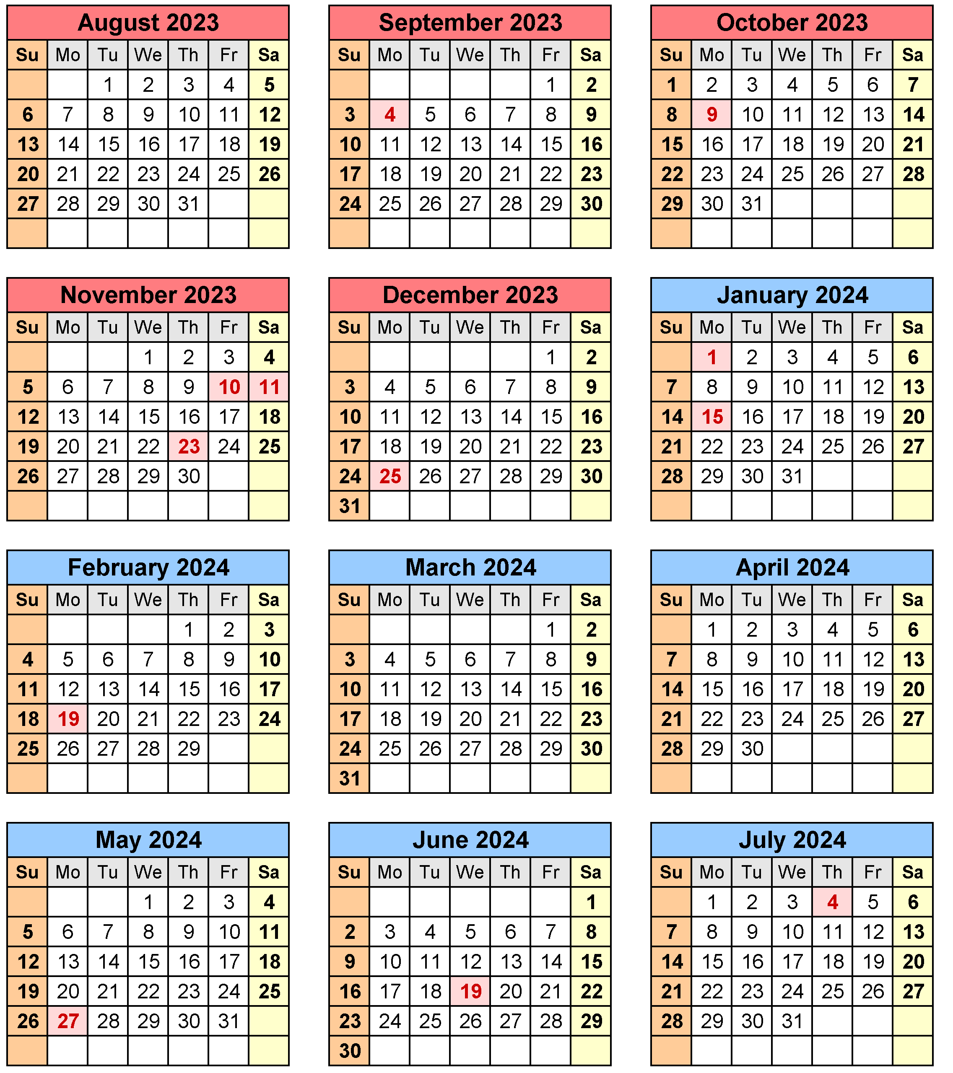

January  1st No School – New Year’s Day  2nd School Resumes  5th - 100th Day of School Celebration  15th No School - Martin Luther King Day (observed)  February  8th Frozen Character Day  14th Favorite Sport Team Spirit Day  19th No School - Presidents Day (observed)  March  4th – 8th Dr. Seuss’ Birthday Celebration Week  12th & 13th Spring / Graduation Pictures 9 AM  21st Hungry Caterpillar Day  28th Community Helper Day  29th No School – Good Friday | April  1st – 5th No School - Spring Break  8th School Resumes  16th & 17th Donuts for Dads  29th Garden Works Field Trip  May  6th – 10th Teacher’s Appreciation Week  14th & 15th Muffins for Moms  27th No School – Memorial Day  24th Super Hero Day  31st Preschool Graduation 9am & 10:30am  31st Last Day of School – School Closes at 12:00pm  June  3rd – 7th No School  10th Summer Camp Starts

