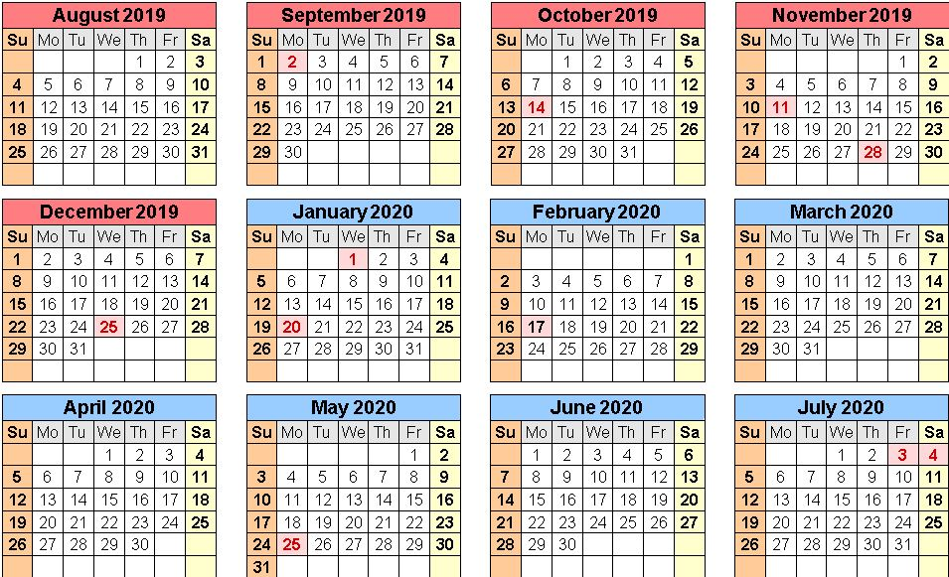
August  1st Parent Orientation (mandatory) 6:30-7:00pm  5th First day of school  27th Back to School Night  September  2nd No School - Labor Day observed  13th Willowbrook Apple Farm Field Trips  October  11th Greenspot Pumpkin Patch Field Trip  17th Great Shake Out  23rd & 24th Fall Picture Day 9 AM  30th & 31st Harvest Parties  November  11th No School - Veterans Day (observed)  25th & 26th Family Thanksgiving Feast  28th & 29th No School - Thanksgiving Break  December  12th Christmas Program 6:30 pm  19th & 20th Christmas Parties  20th School closes at 12:00pm  23rd – 27th No School - Christmas Break | January  1st No School – New Year’s Day  20th No School - Martin Luther King Day (observed)  February  17th No School - Presidents Day observed  March  2nd – 6th Dr. Seuss’ Birthday Celebration Week  6th – Dr. Seuss Trike-a-thon  11th & 12th Spring / Graduation Pictures 9 AM  23rd – 27th No School - Spring Break  30th School Resumes  April  2nd & 3rd Donuts for Dads  10th No School - Good Friday Observed  17th Garden Works Field Trip  23rd Open House 6 – 7 PM  22nd Professional Administrative Day  May  4th - 8th - Teacher’s Appreciation Week  13th & 14th Muffins for Moms  25th No School - Memorial Day  29th Preschool Graduation 10:00 am  29th Last Day of School - Close at 12:00pm

